SECOND TERM EXAMINATION
SUBJECT: MATHEMATICS CLASS: JS2 Time: 2Hours
Instruction: Answer all questions in part A and THREE in B.
PART A (Objective Test: Choose the option from a – d)
- What is the positive difference between the sum of the odd numbers and prime numbers from 1 to 15? A. 23 B. 12 C. 21 D. 14
- Find the H.C.F of 9xy, 18y² . A.18xy B.18xy² C.9y D.3yz
- What is the smallest number by which 84 must be multiplied to make it a perfect square?(A) 2 (B) 3 (C) 7 (D) 21
- What is the range of the inequality on the number line shown below
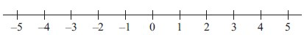
A. x≥-5 B. x≤-2 C. x ≤ 3 D. x≤-1
- Solve 2-x˃12 A.x˂ -5 B.x˃2 C.x˃-2 D.x˂-1
- A triangle has a base of length 6cm and an area of less than 12cm².What can we say about the its height ? A. h˂4 B. h˃5 C. h˃3 D.h˂6
- If a certain number x is added to 15,the result is less than 20. Find the range of the values of x. A.x˃2 B. x˂-5 C. x ˂5 D. x˃4
- Solve 2m$>$3m+1 and represent your result on the number line.
A. B. C.
0

-1
-2
-3
-4
-1

-2
-3
-4
-5
-1

-2
-3
-4
-5

D.
-1

-2
-3
-4
-5

- Factorise 225-64a² A.$\left(15+8a\right)$² B.$\left(15-8a\right)$² C.$\left(15-8a\right)\left(15+8a\right)$ D.$\left(15-4a\right)(15+4a)$
- Factorise 10xy² +5x²y A.10xy(x+y) B. 5xy(2x+y) C.10x(y-1) D. x+1
- The position of each point in the Cartesian plane is given by an ordered pair of numbers called (A) x and y axis (B) x-coordinate (C) y- coordinate (D)coordinates
- Given that y = 5x-7, what is the product of the gradient and the intercept of the linear equation. A. 35 B. -32 C .142 D. -35
- A quadrilateral is a plane shape with ....... sides A.5 B. 6 C. 4 D. 3
- One of the following is a property of parallelogram A. Its opposite sides are unequal B. It has only three angles C. Its opposite angles are equal D.It is three sided.
Use the table below to answer questions 15 to 18 given that y = 2x – 1.
X | -2 | -1 | 0 | 1 | 2 | 3
Y | a | -3 | B | 1 | 3 | C

15. Find the value of a from the table above. A. -3 B. -5 C. -2 D. 4
16. Determine the value of b.A.0 B. -2 C. -3 D. -1
17. Calculate the value of 2a - c. A. 3 B. 15 C. -15 D. -7
18. What is the value of a+ b + c A. – 8 B.-1 C. 12 D. 1
19. The following are examples of quadrilateral except. A. Rectangle B. Square C. Kite D. Circle
20. An ordered pair of numbers such as (2,3), (5,6) etc. are called A. Cartesian B. Plane C. Coordinates D. Rene
Use the figure below to answer questions 21 and 24
 |  |  | 15
Z |  |  | 10 |  |  |  | X
 |  |  | 5
 | -6 | -4 | -2 | 0 | 2 | 4 | 8 | 10 | 12
 | Y |  | -5
 |  |  | -10
 |  |  | -15
21. What are the coordinates of point Y?A.(3,2) B. (-4,-5) C. (2,2) D. (-2,2)
22. What is the position of point X?A.(8,10) B. (-8,-10) C. (10,8) D. (-8,10)
23. The ordinate of point Z is A.10 B. -6 C.7 D. -7
24. The abscissa of X plus ordinate of Z is A. 18 B.14 C.6 D. -6
- A pair of angles whose sum is equal to 180° are A. Acute B. Complementary C. supplementary D. Right angle
- Which of these formulas below is not correct
A.I = PRT B. I = PRT/100 C. R= 100I/RT D. T= 100I/PR
- Calculate the third angle of the triangle in which two of the angles are each 52° A.384° B. 156° C. 76° D. 52°
- Simplify a⁵ x 2a² A. 2a³ B. 2a⁷ C. 2a¹⁰ D. 2a⁵²
- Solve the inequality: 2x + 5 < 5 (x – 2) A. x > 5 B. x> 3 C. x< 5 D. x <2
30. Calculate the simple interest on #20 000 for 2 years at 5%.
A. #4000 B. #3000 C. #1000 D. #2000
31. Express 0.05 as a fraction A. 24/34 B. 9/11 C. 2/5 D. 1/20
32. Solve the equation 7/(x+4) = 6/(7x-1) A. 31/43 B.-31/43 C. 43 D.33
33. When 4 is divided by (x-7),the result is the same as when is divided by (-x-4), find the value of x A.-3/2 B.-2/3 C.2/3 D.3/2
34. Simplify 4x/7 – x/21 A. 21x/11 B. 21x/13 C.11x/21 D.13x/21
35. Find the value of xif 3/8 = 9/x A.3 B. 8 C. 16 D. 24
36. Evaluate: -2x²/x²-y² when x=-2 and y=3 A. 8/5 B. -4/5 C. 7/5 D.5/7
37. Express 870.45 in standard form. A. 8.7045x10⁴ B. 8.7945x10⁶ C. 8.7945x10³ D. 8.7045x10²
38. Approximate 5.7255 to the nearest thousandth. A.5.7 B.5.725 C.5.7255 D.5.726
39. Express N 36.00 as a ratio of N 72.00 A.4:9 B.16:34 C.9:4 D.1:2
40. Find the H.C.F of 18,24 and 30. A.6 B.5 C.4 D.3
41. Find the product of the L.C.M and H.C.F of the following numbers 9,12,18 A. 6 B. 18 C.36 D.108
42. If N 240,000.00 is shared among 3 people in the ratio 5:4:3, what is the least share? A. N 100,000.00
B. N 96,000.00 C. N 80,000.00 D. N 60,000.00
43. A desktop computer is bought for N 45,000.00 and sold for N30,000.00. Find the loss percent.
A. 45.00$\%$ B.33.33$\%$ C.30.00$\%$ D.15.33$\%$
44. Round off 0.01256 to three significant figures. A. 0.01 B. 0.012 C.0.013 D.0.0126
45. What is the place value of 3 in 4321? A.Hundred B. Hundredth C. Tenth D. Thousand
46. Y ≤-2 implies that A. Y is greater than -2 B. Y is less than or equal to -2 C. Y is equal to -2 D. Y is greater than or equal to -2
47. Which of the following is NOT a property of a Rhombus?A. All sides are equal B. sum of angle equal 180° C. opposite angles are equal (d) Diagonal are lines of symmetry.
48. A teacher asks a class to write $\frac{y+6}{2}$ in another way. Three of the answers are I.½(y+6), II. (y+3), III.(½y+3). Which of them is/are correct? A.I only B.II only C. III only D. I and II only
49. Ayo has xkobo .Tunde has 13kobo less than Ayo . The number of kobo they have altogether
Is A.X-13 B.2x -13 C. 2x + 13 D. 13
50. A quadrilateral which has opposite angles equal, no angle equal to 90°; four sides equal .And opposite sides parallel is best described as: A.rhombus B. square C.trapezium D. kite
51. The sum of four times a number and six when divided by eight is greater than 7 .Write this statement in algebraic expressionA.$\frac{6x+4}{8}>7$ B.$\frac{4x+6}{8}$˂7 C.$\frac{4x+6}{8}>7$D.$\frac{4x-6}{8}<$7
52. Simplify: (-5)-(-8) A. -5 B. 3 C.5 D. -3
53. The sum of two consecutive even numbers is 34 .Find the smaller number?A.20 B. 16 C.14 D.12
54. Find one fifth of the difference between 49 and 9. A.7 B. 8 C. 4 D.5
55. Find the value of y in the simple equation, 4y + 3 = 2y – 5 .A. y =-8 B. y =-4 C. y =-5 D. y = 4
56. The co-ordinates of a point (2,-3) mean that; A. y=-2 and x=-3 B. y=-2 and x=3 C. y=-3 and x=-2 D. y=-3 and x=2
57. Solve the inequality; 2 – x ≤7 A. x ≥-1 B. x ≥ 1 C. x ≥- 5 D. x ≤-5
58.Solve the equation; $\frac{3-y}{3}$= 2 A. -3 B. -1 C. 1 D. 3
59.On the plan of a map 1cm represents 10000cm. What is the representative fraction? A. $\frac{1}{1000}$ B.$\frac{1}{10000}$ C.$\frac{1}{100000}$ D. $\frac{1}{1000000}$
60. If 7 is added to a certain number n, the result is greater than 14. Find the range of values of the number. A.n $< -7$ B. n $< -2$C.n$>7$ D. n $<7$
PART B : ESSAY
SECTION A (Answer only one question from this section)
1. a. Mrs. Adeola sells packets of biscuit at N 180.00 each or four for N 660.00. How much is saved by buying four packets at once instead of separately? Hence, what is the percentage gain(Give your answer to 2 d.p)
b. Find the perimeter and the area of the shape below

(2x+5)cm

(5x+10)cm ( 10 marks)

2. (a) Find the HCF of the number 36 and 64
(b)Find the square root of 28900 by factor method
(c)Express 240 as a product of its prime factors in index form.
(d) Find the smallest number by which 540 must be multiplied so that the product is a perfect square.
(e) Express0 0.15 % as a fraction. ( 10 marks)

SECTION B (Answer 2 questions from this section)
3. a. Solve the equation (3x-2)/8 = (8+5x)/2
b. Expand (5a-2b)(2a-3b)
c. Remove the bracket 11x + 3(3x+2y)
d. remove the bracket a(a+b)-b(a+b) ( 10 marks)

4. A car travelling at 90km/h covers 3km in 2min, 6km in 4min, 9km in 6min and soon
a. make a table of values showing how far the car travels in 2min,4min,6min,8min and 10min
b. Using a scale of 2cm to 2min on the horizontal axis and 2cm to 2km on the vertical axis , draw a graph to find:
( i.) how far the car travels in 3 1/2min
(ii)how long it takes the car to travel 10km ( 10 marks)
5. Simplify the following:
a. (7x-4)/10 –(2x+1)/10
b. 3b – (5b-1)/2
c. 5/4a -2/3
d. (4x-1)/3 + 5x
e. 3/5y- 1/5y (10 marks)

MARKING GUIDE FOR Exam: SECOND TERM
SUBJECT: MATHEMATICS CLASS: J SS2
Part A: OBJECTIVES
- A | - C | - D | - A | - A | - A
- C | - A | - C | - B | - D | - D
- C | - C | - B | - D | - C | - B
- D | - C | - B | - A | - A | - A
- C | - C | - C | - B | - A | - D
- D | - A | - D | - C | - D | - A
- D | - D | - D | - A | - D | - D
- B | - D | - A | - B | - B | - A
- B | - A | - C | - B | - B | - B
- B | - D | - C | - A | - B | - C

PART B: THEORY
- (a)1 packet of biscuit is 180.00
4 packets bought after the other is 4×180= 720.00 B1
4 packets bought at once = 660.00
The amount saved by buying four at a time is
720.00 – 660.00 M1
= 60.00
The percentage gained
60/720 ×100/1 M1
= 8.33% A1
(b) Length = (5x+10)cm
Breadth= (2x+5) cm B1
The Perimeter is 2(2x+5) + 2(5x+10)
= 4x+10+10x+20 M1
= 4x+10x+10+20
=(14x+20) cm A1
The area of the shape = (2x+5) ×(5x+10) B ½
10x²+20x+25x+50 M1
(10x²+45x+50)cm² A½
(2x²+9x+10)cm² A1

- (a)
2 | 36 | 64
2 | 18 | 32
 | 9 | 16
M1 for table
H.C.F 2×2=4 A1/2
(b)
2 | 28900
2 | 14450
2 | 7225
2 | 1445
2 | 289
17 | 17
 | 1
M1 for table
28900= 2×2×5×5×17×17
28900=(2×5×17)× (2×5×17) M1
28900 =170×170 B¹/₂
√28900 =170 A1

(c)
2 | 240
2 | 120
2 | 60
2 | 30
3 | 15
5 | 5
 | 1
M1 for the table
240 = 2×2×2×2×3×5
240 = 2⁴×3×5 A1/2

(d)
2 | 540
2 | 270
3 | 135
3 | 45
3 | 15
5 | 5
 | 1
M1 for the table
540= 2²×3³×5³ M ½
The number required = 3×5=15 A 1
(e) 0.15 = 15/100 = 3/20 M ¹/₂ A ½

- (a) (3x-2)/8 = (8x+5)/2
2( 3x-2) = 8(8x+5) B1 for cross multiplying
6x-4 = 64x+40 M1 for removing the bracket
6x-64x=40 +4
-58x/58 = 44/-58 M1 for the solving
X= -22/29 A1
(b) (5a-2b)(2a-3b)
5a(2a-3b)-2b(2a-3b)
10a² -15ab -4ab + 6b² M1
10a²-19ab+6b² A1

(c) 11x +3(3x+2y)
11x+9x + 6y M1
20x + 6y A1
(d) a(a+b)-b(a+b) M1
(a-b)(a+b) A1

Distance(Km) | 3 | 6 | 9 | 12 | 15
Time(Min) | 2 | 4 | 6 | 8 | 10
M1B2 for table
Graph
M1 for the correct labelling of the axes
B2 for all the right points located and A3 for the straight line
B1 for the correct scale( scroll down to See graph)
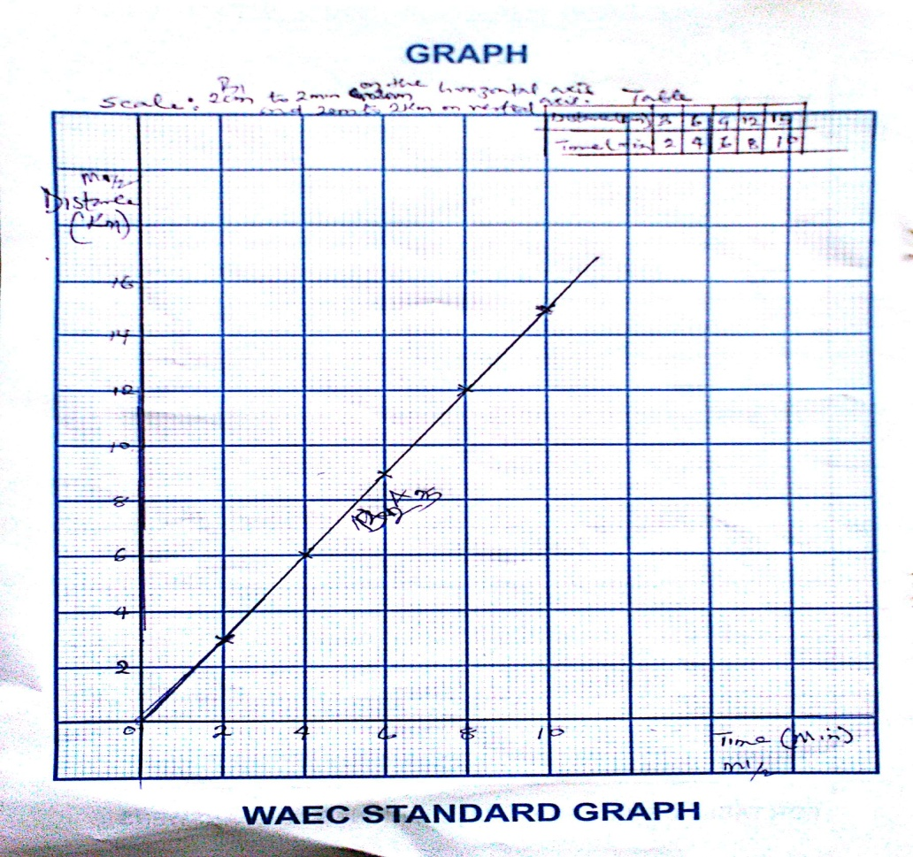

- (a) (7x-4)/10 – (2x+1)/10
(7x-4-2x-1)/10 M1
(5x-5)/10
5(x-1)/10
(x-1)/2 A1
(b) 3b – (5b-1)/2
(6b-5b+1)/2
6b – (5b-1)
2 M1A1
(c) 5/4a -2/3
15-8a
12a M1A1

(d) (4x-1)/3 + 5x
4x-1+15x M1
3
19x -1
3 A1
(e) 3/5y -1/5y
3 - 1
5y M1
2/5y A1

